
THE G8 EXAMINATION
Kenya Certificate of Secondary Education
FORM 4 TERM 2- JUNE 2026

232/2 Paper 2
Physics (Theory)
Time 2 hours

Name …………………………………………….……………………….. Adm Number………………Class………….
Candidate’s Signature ………………….…...…………………………..Date ……………………………………
Instructions to candidates
- Write your name, index number in the spaces provided above.
- Sign and write the date of examination in the spaces provided above.
- This paper consists of two sections: A and B.
- Answer all the questions in sections A and B in the spaces provided.
- All working must be clearly shown.
- Silent non-programmable electronic calculators may be used.
- Candidates should answer the questions in English.
For Examiners Use Only
Section | Question | Candidate’s  Score
A | 1 – 12
B | 13
B | 14
B | 15
B | 16
B | 17
Total Score |  | 80

TURN OVER

SECTION A (25 Marks)
Answer all the questions in this section in the spaces provided
- The following diagram shows the path of light after striking two mirrors at an angle.
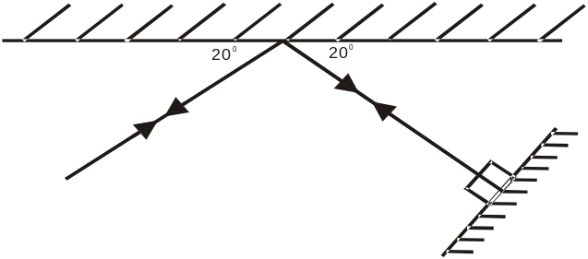

Determine the angle between the two mirrors. (2marks)
.....................................................................................................................................................................................................................................................................................................................................................
- The figure shows the eye defect
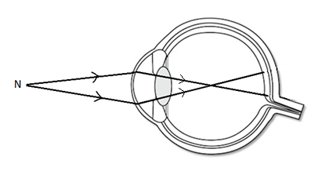
- Name the defect (1mark)
...........................................................................................................................................................................
- State how the defect can be corrected. (1mark)
........................................................................................................................................................................... ...........................................................................................................................................................................
- Explain why a plain sheet of paper and a plane mirror both reflect light yet only the plane mirror forms images while paper cannot form images. (2 marks)
..............................................................................................................................................................................................................................................................................................................................................................................................................................................................................................................................
- What property of light is suggested by the formation of shadows? (1 mark)
…………………………………………………………………………………………………………………

- An object placed 15 cm from a convex lens forms an upright image which is magnified two times. Determine the focal length of the lens. (3 marks)
…………………………………………………………………………………………………………………………………………………………………………………………………………………………………………………………………………………………………………………………………………………………………………………………………………………………………………………………………………
- State one advantage of a lead-acid accumulator over a nickel-iron accumulator. (1 mark)
……………………………………………………………………………………………………………………………………………………………………………………………………………………………………
- An electric bulb rated, 40W is operating on 240 V mains. Determine the resistance of its filament.
(3 marks)
………………………………………………………………………………………………………………………………………………………………………………………………………………………………………………………………………………………………………………………………………………………
- Explain why earthing is necessary in the domestic wiring circuit. (1 mark)
……………………………………………………………………………………………………………………………………………………………………………………………………………………………………
- A positively charged rod is brought near the cap of a leaf electroscope. The cap is the earthed momentarily by touching with the finger. Finally, the rod is withdrawn. The electroscope is found to be negatively charged. Explain how this charge is acquired. (2 marks)
…………………………………………………………………………………………………………………………………………………………………………………………………………………………………………………………………………………………………………………………………………………………………………………………………………………………………………………………………………
- The force on a conductor carrying a current in a magnetic field can be varied by changing, among others, the magnitude of the current and the magnetic field strength. Name any other factor that can be changed to vary the force. (1 mark)
……………………………………………………………………………………………………………………………………………………………………………………………………………………………………
- The table below carries information on the type of radiation, detector and use for some of the electromagnetic radiations.

Type of radiation | Detector | Use
Microwave | Crystal detector, solid state diodes | ......................................................
...................................... | Thermopile, blackened bulb thermometer | Warmth sensation

Fill in the blank spaces. (2 mark)
- The figures below show a convex mirror and a plane mirror of equal aperture
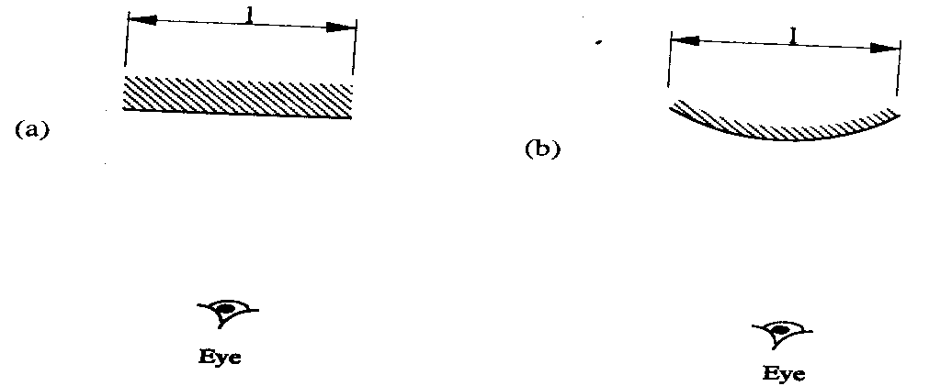
By sketching a pair of incident and reflected rays for each(a) and (b) show how the convex mirror provides to the eye, a wider field of view than a plane mirror. (2marks)

- Water is flowing in a very narrow stream from a water tap (faucet). A negatively-charged plastic strip is held close to the stream of water, as shown in the figure below.
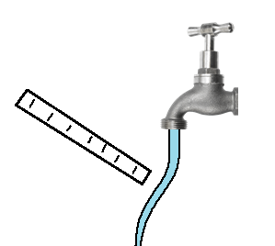

The stream of water moves towards the plastic strip. Explain why this observation. (2marks)
...........................................................................................................................................................................................................................................................................................................................................................................................................................................................................................................................................................................................................

SECTION B (55 MARKS)
- a) Distinguish between transverse waves and longitudinal waves. (2 marks)

...........................................................................................................................................................................................................................................................................................................................................................................................................................................................................................................................................................................................................
b) Plane water waves travels from a deep end into a shallow end in a swimming pool at a
velocity of 4m/s. if the wavelength of these waves in deep end is 6cm and in the shallow end
is 1.5cm, determine the velocity of these waves in the shallow end. (3 marks)

...........................................................................................................................................................................................................................................................................................................................................................................................................................................................................................................................................................................................................
c) State one factor that affects the velocity of sound in a solid. (1mark)

..........................................................................................................................................................................................................................................................................................................................................................................................................................................................................................................................................................................................................
d) A disc siren with 200 holes is rotated at constant speed making 0.5 revolutions per second. If
air is blown towards the holes, calculate:
i) The frequency of sound produced. (3marks)
...........................................................................................................................................................................................................................................................................................................................................................................................................................................................................................................................................................................................................
ii) The wavelength of the sound produced if velocity of sound in air is 340ms⁻¹ (2 marks)
...........................................................................................................................................................................................................................................................................................................................................................................................................................................................................................................................................................................................................
c). State one way of reducing echoes in a room? (1 mark)
.......................................................................................................................................................................................................................................................................................................................................................................................................................................................................................................................................................................................

- a) State one advantage of an alkaline accumulator over lead acid accumulator. (1 mark)
…………………………………………………………………………..…………………………………………………………………………………………………………………………………………………

b) Figure below shows resistors in a circuit.
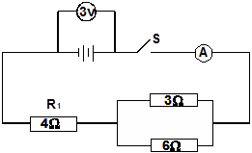

Calculate Current through the 4 Ω resistor. (3 marks)
…………………………………………………………………………..……………………………………………………………………………………………………………………………………………………………………………………………………………………………..…………………………………………………………………………………………………………………………………………………
c) The graph below shows the Voltage current relationship for a certain battery.
Current (A)
0.5

0.4
0.3
0.2
0.1
0
0.5
1.5
1.0
2.0
Voltage (V)

Determine:
(i) The e.m.f of the cell. (1mark)

(ii) The internal resistance of the cell. (3marks)
…………………………………………………………………………..…………………………………………………………………………………………………………………………………..……………………………………………………………………………………………………………………………
(e) Two coils T and S are wound on a soft iron core as shown. T has 1000 turns while S has 600 turns and resistance of 100Ω
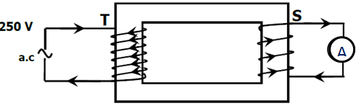
Calculate the maximum current measured by the ammeter. (3marks)
…………………………………………………………………………..…………………………………………………………………………………………………………………………………..……………………………………………………………………………………………………………………………
- (a) The fig. shows as simple form of cathode ray tube, which produces a sharp shadow of a Maltese cross on a fluorescent screen.
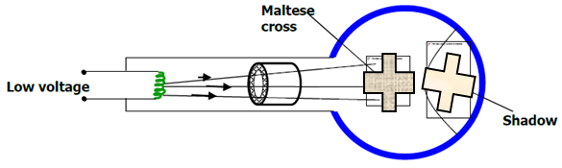
(i) Explain what is meant by cathode rays. (1mark)
…………………………………………………………………………..……………………………………………………………………………………………………………………..…………………………………………
(ii) What property of cathode rays does the fig. above illustrate (1mark)
…………………………………………………………………………..…………………………………………………………………………………………………………………………………..…………………………
(b) State one way of increasing the intensity of the cathode rays produced. (1mark)
…………………………………………………………………………..…………………………………………………………………………………………………………………………………..……………

c). Figure below shows the features of an X-ray tube.
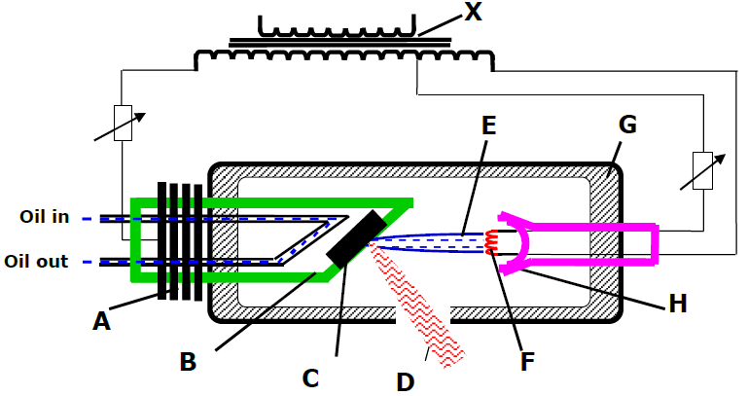
a) Name the parts marked with letters A and H (2marks)
…………………………………………………………………………..…………………………………………………………………………………………………………………………………..……………
b) Why is tungsten or Molybdenum metal most suitable materials for making part C (1mark)
…………………………………………………………………………..…………………………………………………………………………………………………………………………………..……………
c) Why is part B made of thick copper metal (1mark)
…………………………………………………………………………..…………………………………………………………………………………………………………………………………..……………
d) Why should the machine should be surrounded by material G? (1mark)
…………………………………………………………………………..…………………………………………………………………………………………………………………………………..……………
e) Why is the tube evacuated? (1mark)
…………………………………………………………………………..…………………………………………………………………………………………………………………………………..……………
f) What effect will increasing current at F have on x-ray produced? (1mark))
…………………………………………………………………………..…………………………………………………………………………………………………………………………………..……………
- Appliances which draw current from a rings main circuit have a third cable connected to the earth. Give a reason why (1mk)
………………………………………………………………………………………………………………………………………………………………………………………………………………………………
b) In a lighting circuit the wires used are relatively thinner than those of a cooker circuit. Give an explanation for this (1mk)
………………………………………………………………………………………………………………………………………………………………………………………………………………………………
c) A transformer with 6000 turns in the primary circuit and 300 turns in the secondary circuit has its primary circuit connected to a 400V ac source. A heater connected to the secondary circuit produces heat at the rate of 600W. Assuming that the transformer is 100% efficient, determine:
- The voltage in the secondary coil (3mks)

- The current in the primary coil (2mks)

- The current in the secondary coil (2mks)

- .(a) State one difference between a capacitor and a cell. (1mark)
…………………………………………………………………………..…………………………………………………………………………………………………………………………………..……………………………………………………………………………………………………………………………

(b) Sketch the electrostatic field pattern due to the arrangement of the charges shown (1mark)
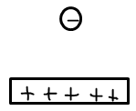
(c)The diagram shows a parallel plate capacitor with a dielectric material in between the plate.
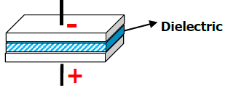
State how each of the following quantities are affected when the dielectric material is pulled out of the parallel plates.
(i) The p.d across the plates. (1mark)
…………………………………………………………………………..…………………………………………………………………………………………………………………………………..……………
(ii) The charge on the plates. (1mark)
…………………………………………………………………………..…………………………………………………………………………………………………………………………………..……………
(iii) The capacitance of the system. (1mark)
…………………………………………………………………………..…………………………………………………………………………………………………………………………………..……………
(d)Three capacitors of 1.5µF, 2.0 µF and 3.0 µF are connected in series to p.d. of 12V. Find the total charge stored in the arrangement (3marks)

(e)The figure below shows a capacitor C being charged.
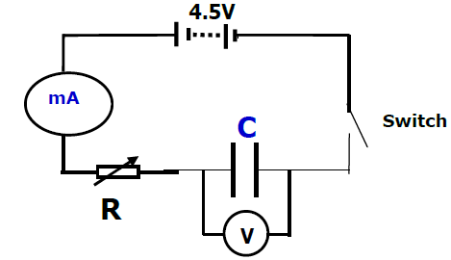
State what would be observed on the following when the switch is closed:
(i) The milliameter (1mark)
…………………………………………………………………………..…………………………………………………………………………………………………………………………………..……………
(ii) The voltmeter (1mark)
…………………………………………………………………………..…………………………………………………………………………………………………………………………………..……………
(iii) Explain how the capacitor is charged. (2marks)
…………………………………………………………………………..…………………………………………………………………………………………………………………………………..……………
…………………………………………………………………………..…………………………………………………………………………………………………………………………………..……………
…………………………………………………………………………..…………………………………………………………………………………………………………………………………..……………
(c) On the axis provided, sketch the graph of voltage (V) against time (t) (1mark)
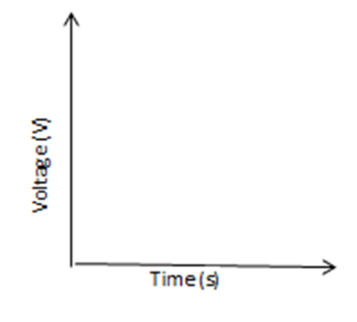

THIS IS THE LAST PRINTED PAGE

